Real Numbers Family Letter
Dear Family,
In this module, Real Numbers, students will use their prior knowledge of the set of rational numbers to develop understanding of the set of real numbers. By having a solid understanding of real numbers, students will be better prepared to study more advanced mathematical concepts in later courses as well as making mathematical connections in everyday life.
What Did Students Learn Previously?
In earlier grades, students understood comparing and ordering rational numbers and computations with rational numbers.
For example, −3.5 > −4.75, because −3.5 is closer to zero. When subtracting rational numbers, −5 – 2 produces the same result as −5 + −2.
What Will Students Learn in This Module?
Roots
- Students will understand how to find and use square and cube roots.
- In most real-world situations, only the positive or principal square root is considered, indicated by a radical sign, √. When both positive and negative square roots are needed, the ± symbol is used before the radical sign. For example, √25 = 5, because 5 x 5 = 25, and ±$√$25 = 5 and −5, because 5 x 5 = 25 and −5 x −5 = 25.
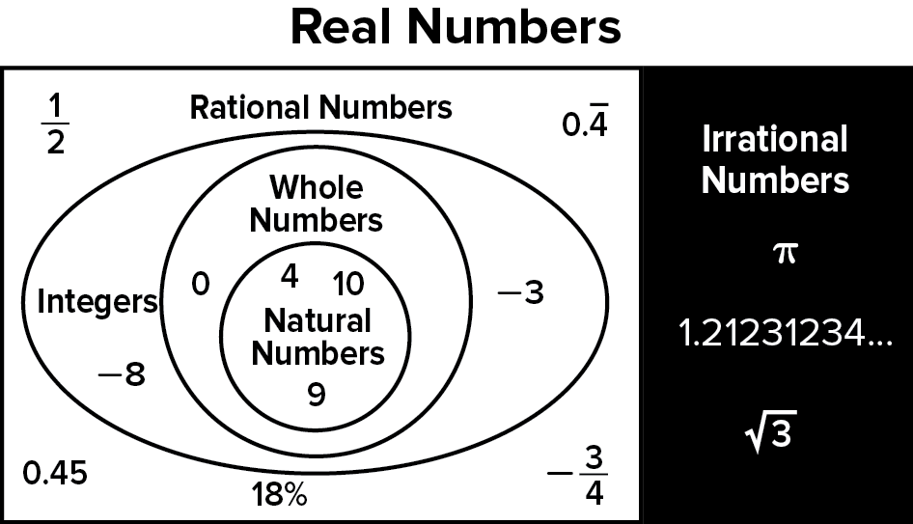
Real Numbers
- Students will understand how to identify and describe sets of numbers in the real number system.
- Students will understand how to compare and order numbers in the real number system.
- Students will understand how to estimate
irrational numbers. Using a number line,
estimating to a place value, and truncating
decimal expansions are methods that can be
used when estimating irrational numbers.

What Vocabulary Terms Will Students Use?

Term | Definition
counterexample | A statement or example that shows a conjecture is false.
cube root | One of three equal factors of a number.
inverse operations | Pairs of operations that undo each other.
irrational number | A number that cannot be expressed as the ratio $\frac{a}{b}$, where a and b are integers and b ≠ 0.
natural numbers | The set of numbers used for counting.
perfect cube | A number whose cube root is an integer.
perfect square | A number whose square root is a whole number.
principal square root | The positive square root of a number.
radical sign | The symbol used to indicate a positive square root, √.
real number | The set of rational numbers together with the set of irrational numbers.
square root | One of the two equal factors of a number.
truncating | A process of approximating a decimal number by eliminating all decimal places past a certain point without rounding.

How You Can Provide Support
- Support your child’s understanding of real numbers by asking them to explain how they are used in everyday life.
  - Irrational Numbers: Discuss the necessity to use approximations of irrational numbers and when you might use those approximations, such as using $π$ to find the circumference or area of a circle.
  - Square Roots: Have your child explain how they would find the dimensions of a square floor, if they knew the area in square feet.
- Encourage your child to have a positive, growth-oriented attitude towards mathematics and their learning.
  - Encourage them to ask questions – both at home and in class. Sometimes, an answer to a question will generate more questions. That’s how you know they are learning!
  - Encourage your child to embrace challenges and remind them that every challenge is an opportunity to learn something new.
  - Celebrate successes – both small and large.
- Contact me to arrange a time to discuss the specifics of your child’s performance and how we can work together to help them succeed in this module.
Sincerely,
______________________ ______________________
(Teacher’s Name) (Email/Phone)

