Transformations, Congruence,
and Similarity Family Letter
Dear Family,
In this module, Transformations, Congruence, and Similarity, students will draw on their knowledge of graphing in the coordinate plane to graph and describe translations, reflections, rotations, and dilations using coordinates. They develop understanding that two figures are congruent or similar if the second figure can be obtained from the first by a series of transformations. They also build their understanding of how similar figures can be used to solve problems involving indirect measurement.
What Did Students Learn Previously?
In previous grades, students graphed points on the coordinate plane. They created symmetric figures and identified their lines of symmetry.
What Will Students Learn in This Module?
Graph Transformations and Determine the Coordinates of Their Images
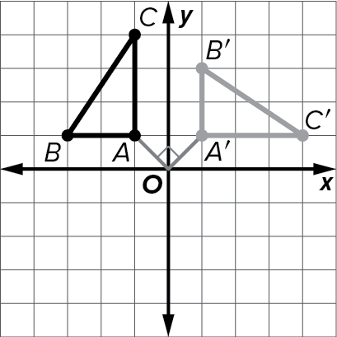
- Students will translate (slide) figures horizontally and vertically on the coordinate plane and identify the coordinates of the translated image.
- Students will reflect figures across horizontal and vertical lines on the coordinate plane and identify the coordinates of the reflected image.
- Students will dilate figures on the coordinate plane and identify the coordinates of the dilated image.
- Students will rotate figures 90֯, 180֯, and 270֯ about a vertex on the coordinate plane and identify the coordinates of the rotated image.

Congruence and Similarity
- Students will determine if two figures are congruent by identifying a sequence of rotations, reflections, and translations that maps one figure onto the other.
- Students will determine if two figures are similar by identifying a sequence of transformations and dilations that maps one figure onto the other.

Indirect Measurement
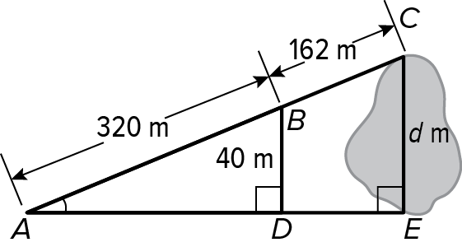
- Students will use similar triangles to solve problems involving indirect measures. For example, the distance across a lake can be estimated by creating similar triangles as shown in the figure. The distance can then be found by writing the proportion $\frac{d}{(320+162)}$ = $\frac{40}{320}$ and solving for d.

What Vocabulary Terms Will Students Use?

Term | Definition
center of dilation | The center point from which dilations are performed.
center of rotation | A fixed point around which shapes move in a circular motion to a new position.
dilation | A transformation that enlarges or reduces a figure by a scale factor.
indirect measurement | A technique using properties of similar polygons to find distances or lengths that are difficult to measure directly.
reflection | A transformation where a figure is flipped over a line. Also called a flip.
rotation | A transformation in which a figure is turned about a fixed point.
similar | If one image can be obtained from another by a sequence of transformations and dilations, then the figures are similar.
transformation | An operation that maps a geometric figure, preimage, onto a new figure, image.
translation | A transformation that slides a figure from one position to another without turning.

How You Can Provide Support
- Support your child’s understanding of transformations, congruence, and similarity by pointing out geometric patterns that you observe on fabrics, floor coverings, architecture, and art.
  - Discuss: Ask your child to identify similar and/or congruent shapes in a pattern and have them describe a series of transformations that could be used to support their conclusion. Point to an angle in the pattern and ask your child to identify corresponding angles in similar or congruent figures in the pattern.
- Encourage your child to have a positive, growth-oriented attitude towards mathematics and their learning.
  - Encourage them to ask questions – both at home and in class. Sometimes, an answer to a question will generate more questions. That’s how you know they are learning!
  - Encourage your child to embrace challenges and remind them that every challenge is an opportunity to learn something new.
  - Celebrate successes – both small and large.
- Contact me to arrange a time to discuss the specifics of your child’s performance and how we can work together to help them succeed in this module.
Sincerely,
______________________ ______________________
(Teacher’s Name) (Email/Phone)

