Area, Surface Area, and Volume Family Letter
Dear Family,
In this module, Area, Surface Area, and Volume, students will develop understanding of circumference and area of circles. They will also build their understanding of volume and surface area and extend that knowledge to composite three-dimensional solids.
What Did Students Learn Previously?
In previous grades, students learned about finding the area of two-dimensional figures and the volume of rectangular prisms.
What Will Students Learn in This Module?
Circles
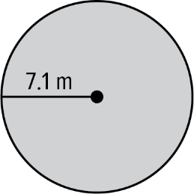
- Students will develop an understanding of the radius and diameter of a circle and how they relate to the circumference of the circle.
- Students will draw on their knowledge of circles to build an understanding of the area of circles.
- Students will also develop an understanding of finding the area of a circle given the circumference.
Area and Surface Area
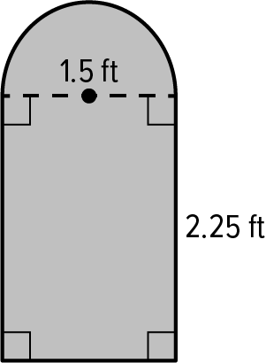
- Students will draw on their knowledge of finding the area of triangles and quadrilaterals to find the area of composite figures.
- Students will draw on their knowledge of nets and finding the area of two-dimensional objects to find the surface area of prisms, pyramids, and composite solids.
- Students will understand how deconstructing composite solids will allow them to find their surface area.
Volume
- Students will use formulas to find the volume of prisms, pyramids, cylinders, cones, spheres, hemispheres, and composite solids.
- Students will use their knowledge to gain an understanding of using volume of a three-dimensional object to find a missing dimension.
- Students will understand how deconstructing composite solids will allow them to find their volume.
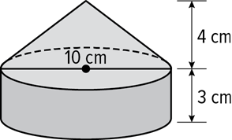
- For example, to find the volume of the composite solid at the right, use the formula for the volume of a cone and the formula for the volume of a cylinder.
Volume_{solid} = Volume_{cone} + Volume_{cylinder}

What Vocabulary Terms Will Students Use?

Term | Definition
area | The measure of the interior surface of a two-dimensional figure.
circumference | The distance around a circle.
composite figure | A figure that is made up of two or more figures.
composite solid | An object made up of more than one solid.
diameter | The distance across a circle through its center.
face | A flat surface of a polyhedron.
lateral face | In a polyhedron, a face that is not a base.
pi | The ratio of the circumference of a circle to its diameter. The Greek letter π represents this number.
prism | A polyhedron with two parallel congruent faces called bases.
pyramid | A polyhedron with one base that is a polygon and three or more triangular faces that meet at a common vertex.
radius | The distance from the center of a circle to any point on the circle.
slant height | The height of each lateral face.
surface area | The sum of the areas of all the surfaces (faces) of a three-dimensional figure.
volume | The measure of the space occupied by a solid.

How You Can Provide Support
- Support your child’s understanding of area, surface area, and volume by having them measure figures and objects found in everyday life, such as food containers and furniture.
- Encourage your child to have a positive, growth-oriented attitude towards mathematics and their learning.
  - Encourage them to ask questions – both at home and in class. Sometimes, an answer to a question will generate more questions. That’s how you know they are learning!
  - Encourage your child to embrace challenges and remind them that every challenge is an opportunity to learn something new.
  - Celebrate successes – both small and large.
- Contact me to arrange a time to discuss the specifics of your child’s performance and how we can work together to help them succeed in this module.
Sincerely,
______________________ ______________________
(Teacher’s Name) (Email/Phone)

