Dear Family,

McGraw-Hill Education is proud to introduce a new mathematics curriculum called Reveal Math.

What Is Reveal Math?
Reveal Math is a K-12 core math curriculum that empowers educators to uncover the mathematician in every student through powerful explorations, rich mathematical discourse, and timely individualized learning opportunities. Our goal was to create a math program that helps students to become mathematical thinkers—to learn how to think, not what to think.

Reveal Math utilizes a seamless blended print and digital delivery and purposeful use of technology to engage students. To ensure student success, our instructional model is based on findings from research on teaching and learning mathematics.
Launch Explore and Develop Reflect and Practice

Why Reveal Math?
Reveal Math is a brand-new program, designed to teach how students learn today.
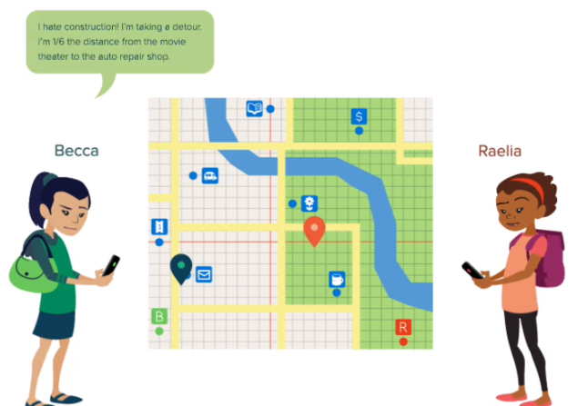
- Purposeful Technology: Reveal Math’s digital resources are not supplementary; they are built into the very fabric of the program. Integrated dynamic explorations, videos, animations, and technology-enhanced items ensure that students stay engaged with learning.
- Conceptual Understanding: Rich problem solving opportunities, questions to inspire students to talk about math, and applications of the math practices provide students with a strong foundation in conceptual understanding, so students aren’t just grinding through problems.
Reveal Geometry, Lesson 1-6, Explore
- Math Positivity: Reveal Math encourages a math-positive classroom with strategies for helping your child develop a growth mindset, activities for students to work with their classmates in teams and groups, and learning statements with a positive “I Can” focus.

How Can I Help My Child?
Reveal Math includes several resources in the Digital Student Center that can help you support your child at home.
- Review Lessons: Each lesson includes a Review activity to help students brush up on previously learned concepts they may have forgotten. If your child’s teacher assigns this lesson, you may be able to work with your child to review previously learned math skills.

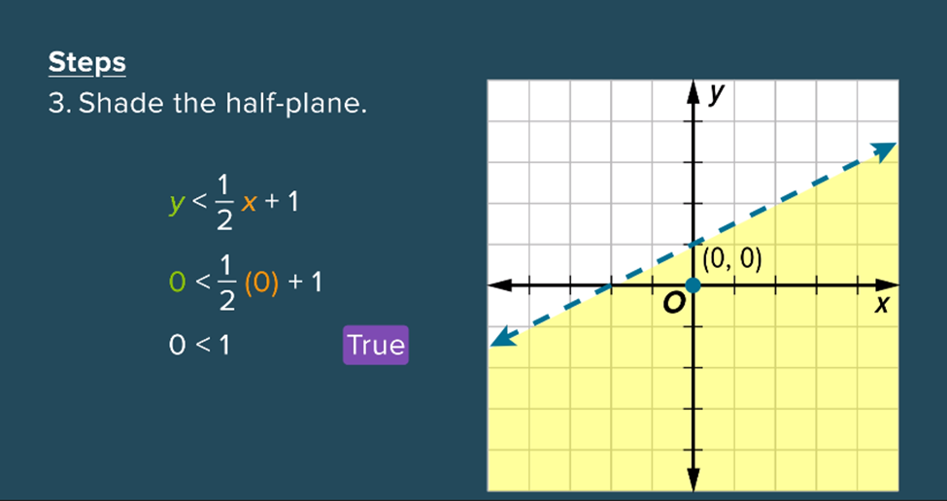
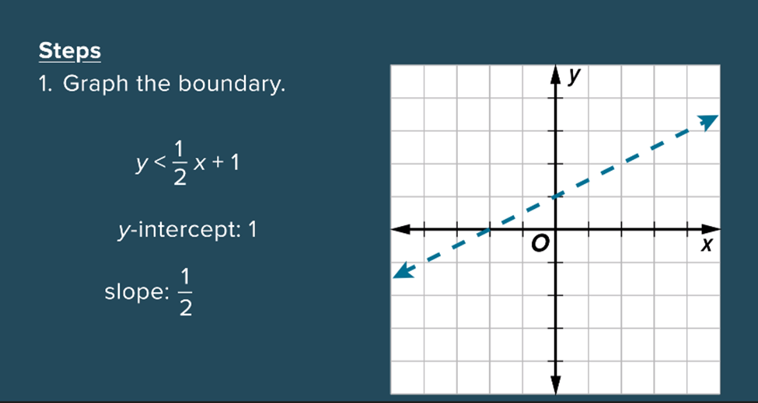
- Videos: A wealth of videos are embedded in the content to help students—and parents—gain conceptual understanding, review algorithms, and help with at-home assignments. In particular, look for:
- Foldables Videos in Course Materials
- BrainPOP Videos on Lesson Landing Pages
- Graphing Calculator Videos embedded within lessons
- Animations embedded within lessons
- Personal Tutors embedded within Extra Examples

How Do I Get Started?
Animation, Reveal Algebra 1, Lesson 6-5
Accessing the digital resources is safe, secure, and simple.
View the minimum system requirements at https://www.help.k12.mhedu.com/systemcheck/ to ensure that your devices are compatible.
Log into the Digital Student Center at https://my.mheducation.com/.
Access your child’s account by using the username and password provided by their teacher.
Student Name:
Username:
Password

Run into Trouble?
If you have classroom-specific questions, please contact your child’s teacher.
If you need help with the Reveal Math digital materials, go to
https://www.mheducation.com/prek-12/contact.html.

Stay tuned to see how your student’s potential will be revealed!

Sincerely,
McGraw-Hill Education

