Linear Relationships and Slope Family Letter
Dear Family,
In this module, Linear Relationships and Slope, students will draw on their knowledge of unit rates and proportional relationships to understand slope and will use similar triangles to explain why the slope is the same between any two points on a line. They will explore similarities and differences between linear and proportional models, and derive the linear equation y = mx + b.
What Did Students Learn Previously?
In previous modules, students graphed proportional relationships on the coordinate plane. They learned that if the graph of a line contains the point (0, 0), then the graph represents a proportional relationship, and the point (1, r) shows the constant of proportionality. For example, the line below passes through the point (0, 0). This means that the graph represents a proportional relationship and the point (1, 2) indicates the constant of proportionality, 2.
What Will Students Learn in This Module?
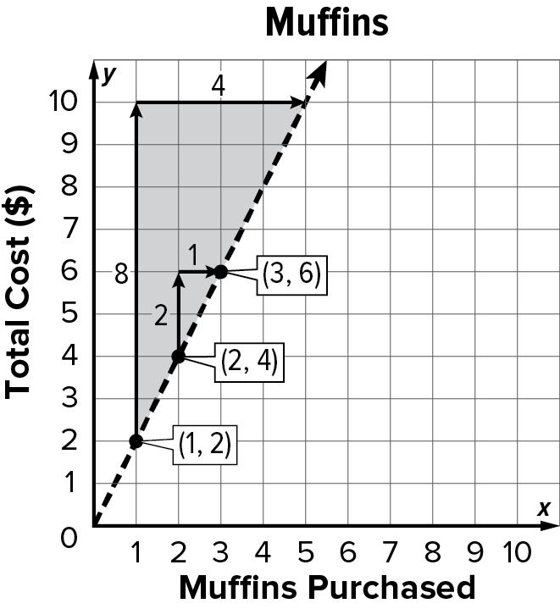
Slope
- Students will recognize that, in proportional relationships, the slope is the unit rate. In the graph shown, the unit rate is $2.00 per muffin, so the slope is 2.
- Students will learn slope as the ratio $\frac{rise}{run}$. They will construct right triangles to help them determine rise and run, and then calculate the slope ratio. For example, the triangle shaded in the graph has a rise of 8 units and a run of 4 units, for a slope of $\frac{8}{4}$, or 2.
- Students will use the slope formula, $\frac{y1 – y2}{x1 – x2}$, to calculate the slope from two points, (x₁, y₁) and (x₂, y₂). For example, the slope between the points (2, 4) and (3, 6) can be found by writing $\frac{6 - 4}{3 - 2}$= $\frac{2}{1}$= 2
Proportional and Linear Relationships
- Students will learn that the ratio $\frac{y}{x}$ is equivalent for every point (x, y) on the line, and it is equal to the slope. For example, in the graph above $\frac{6}{3}$= 2 and $\frac{4}{2}$= 2.
- Students will learn that the graph of a non-proportional linear relationship does not pass through the origin, and the ratio $\frac{y}{x}$ is not the same for every point on the line.
What Vocabulary Terms Will Students Use?

Term | Definition
constant rate change | An unchanging rate which describes how one quantity changes in relation to another.
slope | The rate of change between any two points on a line as described by the ratio $\frac{rise}{run}$.
rise | The vertical change between two points on a line.
run | The horizontal change between two points on a line.
slope triangles | Similar right triangles whose hypotenuses lie on the line of a linear equation.
linear equation | An equation whose graph is a straight line.
slope-intercept form | A linear equation written in the form y = mx + b, where m is the slope and b is the y-intercept.
y-intercept | The coordinate of the point where the line crosses the y-axis.
direct variation | A relationship between two variable quantities with a constant ratio, resulting in a proportional linear relationship.
constant of proportionality  or constant of variation | The constant ratio in a proportional (direct variation) linear relationship.

How You Can Provide Support
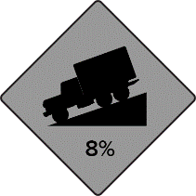
- Support your child’s understanding of linear equations by asking them to explain how they can use reasoning about slope in everyday life.
- Driving: Ask your child to explain the rise and run indicated by Hill with Grade road signs. For example, in the sign shown, your child might say that cars will descend 8 feet every 100 feet that they travel.
- Stairs: When you encounter a staircase, ask your child to estimate its rise and run. Discuss how the staircase might be different if the run was increased or decreased.
- Encourage your child to have a positive, growth-oriented attitude towards mathematics and their learning.
  - Encourage them to ask questions – both at home and in class. Sometimes, an answer to a question will generate more questions. That’s how you know they are learning!
  - Encourage your child to embrace challenges and remind them that every challenge is an opportunity to learn something new.
  - Celebrate successes – both small and large.
- Contact me to arrange a time to discuss the specifics of your child’s performance and how we can work together to help them succeed in this module.
Sincerely,
______________________ ______________________
(Teacher’s Name) (Email/Phone)

