Measure Figures Family Letter
Dear Family,
In this module, Measure Figures, students will build understanding of the parts of a circle and learn to measure circles. They will also build their understanding of volume and surface area and extend that knowledge to composite figures.
What Did Students Learn Previously?
In previous grades students learned about finding the area of two-dimensional figures and finding the area and surface area of three-dimensional figures.
What Will Students Learn in This Module?
Circles
- Students will develop an understanding of the radius and diameter of a circle and how they relate to the circumference of the circle.
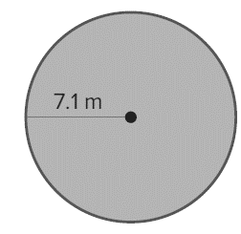
- Students will draw on their knowledge of circles to build an understanding of the area of circles. Students will also develop an understanding of finding the area of a circle given the circumference.
- For example, in the figure shown the circumference would be
C = 2(π)(7.1 m) = 14.2π m ≈ 44.6 m. The area is
A = π (7.1²) = 50.41π m² ≈ 158.4 m².
Composite Figures
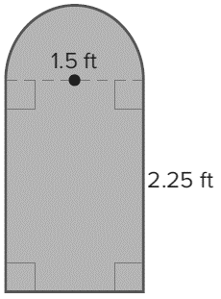
- Students will draw on their knowledge of finding the area of triangles and quadrilaterals to gain fluency in finding the area of composite figures.
- For example, to find the area of the figure shown the student would need to find the area of the rectangle and the area of the semicircle.
A = (2.25)(1.5) + $\frac{1}{2}$(π)(1.5²) ≈ 3.375 + .884 ≈ 4.26 ft²
Volume and Surface Area
- Students will draw on their knowledge of finding area to gain fluency in finding the volume of rectangular prisms, triangular prisms and pyramids. They will use their knowledge to gain an understanding of using volume of a three-dimensional object to find a missing dimension.
- Students will draw on their knowledge of nets and their knowledge of finding the area of two-dimensional objects to gain fluency in finding the surface area of prisms and pyramids.
What Vocabulary Terms Will Students Use?

Term | Definition
area | The measure of the interior surface of a two-dimensional figure.
center | The point from which all points on a circle are the same distance.
circle | The set of all points in a plane that are the same distance from a given point called the center.
circumference | The distance around a circle.
composite figure | A figure that is made up of two or more figures.
diameter | The distance across a circle through its center.
face | A flat surface of a polyhedron.
lateral face | In a polyhedron, a face that is not a base.
pi | The ratio of the circumference of a circle to its diameter. The Greek letter π represents this number.
radius | The distance from the center of a circle to any point on the circle.
prism | A polyhedron with two parallel congruent faces called bases.
pyramid | A polyhedron with one base that is a polygon and three or more triangular faces that meet at a common vertex.
semicircle | Half of a circle.
slant height | The height of each lateral face.
surface area | The sum of the areas of all the surfaces (faces) of a three-dimensional figure.
volume | The number of cubic units needed to fill the space occupied by a solid.

How You Can Provide Support
- Support your child’s understanding of measuring figures by pointing out figures and terms that were studied in this section.
- Encourage your child to have a positive, growth-oriented attitude towards mathematics and their learning.
  - Encourage them to ask questions – both at home and in class. Sometimes, an answer to a question will generate more questions. That’s how you know they are learning!
  - Encourage your child to embrace challenges and remind them that every challenge is an opportunity to learn something new.
  - Celebrate successes – both small and large.
- Contact me to arrange a time to discuss the specifics of your child’s performance and how we can work together to help them succeed in this module.
Sincerely,
______________________ ______________________
(Teacher’s Name) (Email/Phone)

