Proportional Relationships Family Letter
Dear Family,
In this module, Proportional Relationships, students will use their prior knowledge of ratios and rates to develop understanding of proportional relationships. Proportional reasoning is a foundational topic for middle school mathematics, with applications in algebra, geometry, probability, statistics, and everyday life!
What Did Students Learn Previously?
In a previous grade, students used rate and ratio reasoning to solve real-world and mathematical problems.
For example, a basketball player made 3 out of every 5 free throws during a game. By using ratio reasoning, such as bar diagrams, double number lines, or tables, students determined that the basketball player made 21 out of 35 free throws, because 3 out of 5 and 21 out of 35 are equivalent ratios.

What Will Students Learn in This Module?
Proportional Relationships
- Students will apply and extend their understanding of ratios and rates to develop foundational understanding of proportional relationships.
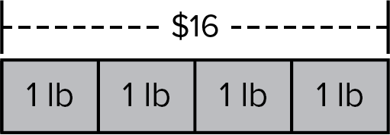
- In the bar diagram, four pounds cost a total of $16. This means that each pound costs $4. The unit rate is $4 per pound.
- In order for a relationship to be in a proportional relationship, the second unit rate must also be $4 per pound.
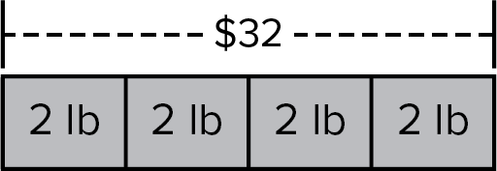
- In this second bar diagram, eight pounds cost a total of $32. This means that each two-pound section costs $8. By using rate reasoning, this means that each pound costs $4. Because the ratios were maintained, this is a proportional relationship.
- Proportional relationships can be shown in tables, graphs, and equations. In each representation, the constant ratio (or constant of proportionality) must be maintained.
Proportions
- A proportion is an equation stating that two ratios are equivalent, for example . Because each ratio is equivalent to , or 4 to 1, this is a proportion.
- Students will solve problems involving proportional relationships using words, ratio tables, graphs, or equations.

What Vocabulary Terms Will Students Use?

Term | Definition
constant of proportionality | The constant ratio in a proportional relationship. It has the same value as the unit rate.
nonproportional | Two quantities are nonproportional if the ratios comparing them are not equivalent.
proportion | An equation stating that two ratios are equivalent.
proportional | Two quantities are proportional if the ratios comparing them are equivalent.
proportional relationship | Two quantities that vary and have a constant ratio between them.
unit rate | A comparison of a first quantity per every 1 unit of a second quantity.

How You Can Provide Support
- Support your child’s understanding of proportional relationships by asking them to explain how they can use proportions to solve problems in everyday life.
  - Shopping: Find the total cost of a certain number of items, such as oranges, based on the cost of two of the items.
  - Driving: Find the distance traveled in 3 hours if the speed you traveled was constant.
  - Home Improvement: Find the number of gallons of paint needed to cover the four walls of a room given the number of square feet one gallon of paint covers.
- Encourage your child to have a positive, growth-oriented attitude towards mathematics and their learning.
  - Encourage them to ask questions – both at home and in class. Sometimes, an answer to a question will generate more questions. That’s how you know they are learning!
  - Encourage your child to embrace challenges and remind them that every challenge is an opportunity to learn something new.
  - Celebrate successes – both small and large.
- Contact me to arrange a time to discuss the specifics of your child’s performance and how we can work together to help them succeed in this module.

Sincerely,
______________________ ______________________
(Teacher’s Name) (Email/Phone)

